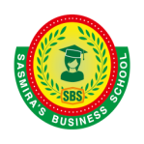
SASMIRA’S BUSINESS SCHOOL
Sasmira Marg, Worli, Mumbai – 400 030

Placements

INTRODUCTION

SASMIRA’S Business School believes in integrating the classroom learning and studies to be leveled up with corporate experience. The fervent need to build a bridge between college visions and student expectiations, led to formation of Placement Cell. The placement cell plays an instrumental role in developing and sustaining a mutually beneficial long term relationship with the industry. In addition to that, with the right corporate exposure and applied knowledge, the placements provide the impetus to the students to move forward in the right direction. Further, the placement cell ensures that the industry benefits from the students in terms of taking up roles and responsibilities and contributing to the growth of the organization.

Objective of Placement Cell
- To ensure the student starts the career and moves forward in the right direction for better quality living.
- To provide ultimate satisfaction to our valuable students by offering the companies of their choice according to their eligibility and potentiality.
- To build the bridge between industry and academia.

Activities undertaken by the department
  - Student Development Workshops: To optimize the student's strengths and manage their limitations, both personally and professionally.
  - Employability Skills Enhancement Programs: To teach and integrate the appropriate skills needed from an employer's perspective.
  - Summer Internship Program: Collaboration with companies so that the students surpass expectations, contribute value to organizational productivity, and secure pre-placement offers.
  - Industry Expert Interaction- To upgrade the students’ market knowledge and keep them updated about the latest industry trends.
  - Corporate Career Counselling: Enabling students to choose the right career path, set and achieve actionable goals to improve their life at work.
  - Short Term Live Projects: To expose students to a practical working environment, test their skills, and use what they learn to accomplish organizational goals.
  - MoU’s with Corporate/Industry: Partnering initiatives based on training, placement, internship, visits, student enlightenment, live projects and other areas of symbiotic association

  - Institute Industry Interface initiatives to bridge the gap between industry and academia.
  - HR Meets & Conclaves: To educate students about corporate expectations and the hiring processes used and develop networks.
  - Training & Development: Addressing students' training needs, from spoken English to corporate communication skills, leadership and personality development, stress and time management, to the improvement of employability skills and emotional intelligence.

Placement Process
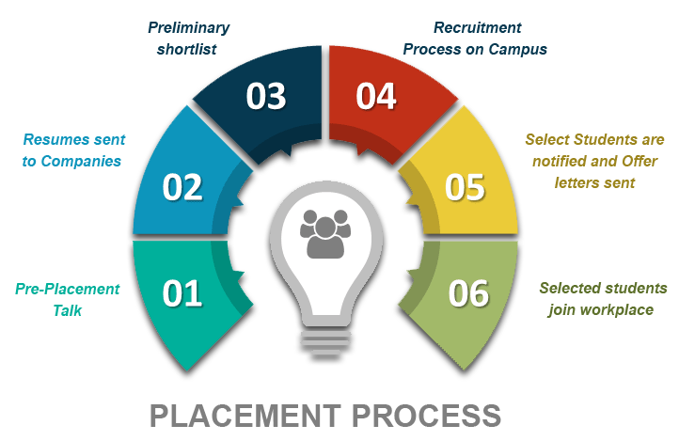

Final Placement Report
PLACEMENT REPORT PGDM BATCH (2021-2023)
 | 05.23 LPA |  | Average Package
 | 10.00 LPA |  | Higher Domestic Package
 | 82.00% |  | Students Placed
 | 05 |  | Students not applied to any company
 | 06 |  | Students are either entrepreneurs / joining their family business, or opting for further studies.
 | 91.58% |  | Total placed students

Prominent Companies Visited for Campus Placements :
Nomura, Insync Analytics, Marathon Realty Pvt. Ltd., Guardians Group, NoBroker, Decimal Point, Visible Alpha, Amul Ltd., LG India, Capegemini, Wipro, N. J. Wealth, Adonmo, Samsung, TCS, Blue Stone, Kotak Mahindra Bank, Ally Venture, Indusind Bank, Himalaya, Mecklai Financial Services.

